Objective :
- To make the student learn an object oriented way of solving problems

- To teach the student to write programs in Java to solve the problems

Recommended Systems/Software Requirements:
- Intel based desktop PC with minimum of 166 MHZ or faster processor with atleast 64 MB RAM and 100 MB free disk space

- JDK kit. Recommended

INDEX

Week1:
a) Write a java program that print all real solutions to the quadratic equation
ax²⁺bx+c=0. Read in a,b,c and use the quadratic formula. If the discriminant
b²-4ac is negative display a message stating that there are no real solutions.
b) The Fibonacci sequence is defined by the following rule. The first two values in the
sequence are 1 and 1. Every subsequent values preceding it. Write a java program that
uses both recursive and non-recursive functions to print the n^{th} value in the Fibonacci
sequence.

Week2:
a) Write a Java program that prompts the user for an integer and then prints out all prime
numbers up to that integer
b) Write a Java program to multiply two given matrices
c) Write a java program that reads a line of integers, and then displays each integers, and
the sum of all the integers(use string tokenizer class java.util)

Week3:
a) Write a Java program that checks whether a given string is a palindrome or not.
Ex: MADAM is a palindrome
b) Write a Java program for sorting a given list of names in ascending order
c) Write a Java program to make frequency count of words in a given text.

Week4:
a) Write a Java program that reads file name from the user then displays information
about whether the file exists, whether the file is readable, whether the file is writable,
the type of the file and length of the file in bytes.
b) Write a Java program that reads a file and displays the file and displays the file on the
screen, with a line number before each line.
c) Write a Java program that displays the number of characters, lines and words in a text
file.

Week5:
a) Write a Java program that:
i) Implements stack ADT.
ii) Converts infix expression into Postfix form
iii) Evaluates the postfix expression

Week6:
a) Develop an applet that displays a simple message.
b) Develop an applet that receives an integer in one text field, and computes its factorial
Value and returns it in another text field, when the button named “Compute” is
clicked.

Week7:
Write a Java program that works as a simple calculator. Use a grid layout to arrange buttons for the digits and for the +, -,*, % operations. Add a text field to display the result.

Week8:
a) Write a Java program fro handling mouse and key events.

Week9:
a) Write a Java program that creates three threads. First thread displays “Good Morning” every one second, the second thread displays “Hello” every two seconds and the third thread displays “Welcome” every three seconds.
b) write a Java program that correctly implements producer consumer problem using the concept of inter thread communication.

Week10:
Write a program that creates a user interface to perform integer divisions. The user enters two numbers in the textfields, Num1 and Num2. The division of Num1 and Num2 is displayed in the Result field when the Divide button is clicked. If Num1 or Num2 were not an integer, the program would throw a NumberFormatException. If Num2 were Zero, the program would throw an ArithmeticException Display the exception in a message dialog box.

Week11:
a) Write a java program that simulates a traffic light. The program lets the user select one of three lights: red, yellow, or green. When a radio button is selected, the light is turned on, and only one light can be on at a time No light is on when the program starts.
b) Write a java program that allows the user to draw lines, rectangles and ovals.

Week12:
a) Write a java program to create an abstract class named Shape that contains an empty method named numberOfSides ( ).Provide three classes named Trapezoid, Triangle and Hexagon such that each one of the classes extends the class Shape. Each one of the classes contains only the method numberOfSides ( ) that shows the number of sides in the given geometrical figures.
b) Suppose that a table named Table.txt is stored in a text file. The first line in the file is the header, and the remaining lines correspond to rows in the table. The elements are separated by commas. Write a java program to display the using Jtable component.

/* Write a java program that print all real solutions to the quadratic equation
ax²⁺bx+c=0. Read in a,b,c and use the quadratic formula. If the discriminant
b²-4ac is negative display a message stating that there are no real solutions.*/

import java.io.*;
class RealDemo
{
public static void main(String[] args)throws IOException
{
BufferedReader br=
newBufferedReader(newInputStreamReader(System.in));
System.out.println("Enter the values of a,b&c");
int a=Integer.parseInt(br.readLine());
int b=Integer.parseInt(br.readLine());
int c=Integer.parseInt(br.readLine());
int dis=b*b-(4*a*c);
if(dis<0)
{
System.out.println("there are no real solutions");
}
else
{
float sol1=(float)((-b)+Math.sqrt(dis))/(2*a);
float sol2=(float)((-b)-Math.sqrt(dis))/(2*a);
System.out.println("real solutions of the problem:");
System.out.println(sol1+"\n"+sol2);
}
}
}

Output:
Enter the values of a,b&c:
2
3
4
there are no real solutions

1

/* The Fibonacci sequence is defined by the following rule. The first two values in the sequence are 1 and 1. Every subsequent values preceding it. Write a java program that uses both recursive and non-recursive functions to print the n^{th} value in the Fibonacci sequence*/
//Non-recursive Method
import java.io.*;
class Fibonac
{
int a=1,b=1;
void fib(int n)
{
if(n>0)
{
System.out.println("fibonacci series is:");
System.out.println(1+"\n"+1);

for(int i=n;i>0;i--)
{
int c=a+b;
a=b;
b=c;
System.out.println(c);
}
}
else
System.out.println("no series");
}
}
class FibDemo2
{
public static void main(String[] args)throws IOException
{
Fibonac f=new Fibonac();
BufferedReader br=
new BufferedReader(new InputStreamReader(System.in));
System.out.println("enter n value:");
int n=Integer.parseInt(br.readLine());
f.fib(n);
}
}

2

Output:
Enter the n value:
5
Fibonacci series is:
1
1
2
3
5

3

// Recursive method

import java.io.*;
class Rfebonacci
{
public static void main(String args[])
{
int n,i;
BufferedReader br=
new BufferedReader(new InputStreamReader(System.in));
System.out.println("enter n value:");
n=Integer.parseInt(br.readLine());
System.out.println("febonacci series");
for(i=0;i<n;i++)
System.out.println(feb(i));
}
static int feb(int n)
{
if(n==0)
return 0;
if(n==1)
return 1;
else
return feb(n-1)+feb(n-2);
}
}

Output:
Enter the n value:
5
Fibonacci series:
0
1
1
2
3

4

/* Write a java program that prompts the user for an integer and then prints out all prime numbers up to that integer*/

import java.io.*;
class PrimeDemo
{
public static void main(String[] args)throws IOException
{
BufferedReader br=
new BufferedReader(new InputStreamReader(System.in));
System.out.println("Enter the number:");
int n=Integer.parseInt(br.readLine());
int i,num=2;
boolean prime;
System.out.println("prime no's are:");
while(num<n)
{
prime=true;
for(i=2;i<=num/2;++i)
if(num%i==0)
{
prime=false;
break;
}
if(prime==true)
System.out.println(num);
num++;
}
}
}

Output:

Enter the number:
7
prime no’s are:
2
3
5

5

/* Write a java program to multiply two given matrices*/

import java.io.*;
class Matrix1
{
public static void main(String[] args)throws IOException
{
int i,j,k;
BufferedReader br=
new BufferedReader(new InputStreamReader(System.in));
System.out.println("enter the order of matA:");
int m=Integer.parseInt(br.readLine());
int n=Integer.parseInt(br.readLine());
int A[][]=new int[m][n];
System.out.println("enter the order of matB:");
int p=Integer.parseInt(br.readLine());
int q=Integer.parseInt(br.readLine());
int B[][]=new int[p][q];
System.out.println("enter matA elements:");
for(i=0;i<m;i++)
for(j=0;j<n;j++)
A[i][j]=Integer.parseInt(br.readLine());

System.out.println("enter matB elements:");
for(i=0;i<p;i++)
for(j=0;j<q;j++)
B[i][j]=Integer.parseInt(br.readLine());
System.out.println("the matA is:");
for(i=0;i<m;i++)
{
for(j=0;j<n;j++)
System.out.print(A[i][j]+” “);
System.out.println();
}
System.out.println("the matB is:");
for(i=0;i<p;i++)
{
for(j=0;j<q;j++)
System.out.print(B[i][j]+” “);
System.out.println();
}

6

int C[][]=new int[m][q];
if(n==p)
{
for(i=0;i<m;i++)
{
for(j=0;j<q;j++)
{
C[i][j]=0;
for(k=0;k<n;k++)
C[i][j]=C[i][j]+A[i][k]*B[k][j];
}
}
System.out.println("the product of matA and matB:");
for(i=0;i<m;i++)
{
for(j=0;j<q;j++)
System.out.print(C[i][j]+" ");
System.out.println();
}
}
else
System.out.println("Matrix multiplication is not possible
}
}

7

Output:

enter the order of matA:
2
3
enter the order of matB:
3
2
enter matA elements:
1
2
3
1
2
3
enter matB elements:
1
2
3
1
2
3
the matA is:
1 2 3
1 2 3
the matB is:
1 2
3 1
2 3
the product of matA and matB
13 13
13 13

8

/* Write a java program that reads a line of integers, and then displays each integers, and the sum of all the integers(use string tokenizer class)*/

import java.util.*;
import java.io.*;
class Tokenizer
{
public static void main(String[] args)throws IOException
{
int sum=0,i
BufferedReader br=
new BufferedReader(new InputStreamReader(System.in));
System.out.println("enter string object:");
String ob=br.readLine();
StringTokenizer st=new StringTokenizer(ob);
System.out.println("no.of tokens are:"+st1.countTokens());
System.out.println(“tokens are:”);
while(st1.hasMoreTokens())
{
i=Integer.parseInt(st.nextToken());
sum=sum+i;
System.out.println(" "+i);
}
System.out.println("summation:"+sum);
}
}

Output:
enter the string object:
3 4 5
no. of tokens are:3
tokens are:
3
4
5
summation:12

9

/* Write a java program that checks whether a given string is a palindrome or not. Ex: MADAM is a palindrome*/

import java.io.*;
class Palindrome
{
public static void main(String[] args)throws IOException
{
int k=0;
String str=new String();
BufferedReader br=
new BufferedReader(new InputStreamReader(System.in));
System.out.println("Enter string");
str=br.readLine();
int n=str.length();
char ch[]=new char[n];
for(int i=n-1;i>=0;i--)
{
ch[k++]=str.charAt(i);
}
String str1=new String(ch);
if(str1.equals(str))
System.out.println("Given string is palindrome");
else
System.out.println("Given string is not palindrome");
}
}

Output:

Enter string
Malayalam
Given string is palindrome

10

/* Write a java program for sorting a given list of names in ascending order*/

import java.io.*;
class SortString
{
public static void main(String[] args) throws IOException
{
BufferedReader br=
new BufferedReader(new InputStreamReader(System.in));
System.out.println("Enter how many strings:");
int n=Integer.parseInt(br.readLine());
String arr[]=new String[n];
System.out.println("Enter the strings:");
for(int m=0;m<n;m++)
{
arr[m]=br.readLine();
}
System.out.println("The sorted list:");
for(int j=0;j<arr.length;j++)
{
for(int i=j+1;i<arr.length;i++)
{
if(arr[i].compareTo(arr[j])<0)
{
String t=arr[j];
arr[j]=arr[i];
arr[i]=t;
}
}
System.out.println(arr[j]);
}
}
}

11

Output:
Enter how many strings:
bat
rat
ill
rub
mat
The sorted list:
bat
ill
mat
rat
rub

12

/* Write a Java program to make frequency count of words in a given text.*/

class Wordcount
{
public static void main(String args[])
{
int count[]=new int[a.length];
int i,j;
boolean checked[]=new boolean[a.length];
for(i=0;i<a.length;i++)
{
checked[i]=false;
count[i]=1;
}
for(i=0;i<a.length-1;i++)
{
for(j=i+1;j<a.length;j++)
{
if(!checked[j])
{
if(a[i].equals(a[j]))
{
count[i]++;
checked[j]=true;
}
}
}
}
for(i=0;i<a.length;i++)
if(!checked[i])
System.out.println("frequency count of "+a[i]+" "+count[i]);
}
}

Output:
D:\>java Wordcount java is an oop oop
Frequency count of java 1
Frequency count of is 1
Frequency count of an1
Frequency count of oop 2

13

/* Write a java program that reads file name from the user then displays information about whether the file exists, whether the file is readable, whether the file is writable, the type of the file and length of the file in bytes.*/
import java.io.File;
class FileDemo
{
static void p(String s)
{
System.out.println(s);
}
public static void main(String[] args)
{
File f1=new File("/java/COPYRIGHT");
p("File Name:"+f1.getName());
p("Path:"+f1.getPath());
p("Abs path:"+f1.getAbsolutePath());
p("Parent:"+f1.getParent());
p(f1.exists()?"exists":"does not exist");
p(f1.canWrite()?"is writeable":"is not writeable");
p(f1.canRead()?"is readable":"is not readable");
p("is"+(f1.isDirectory()?" ":"not"+"a directory"));
p(f1.isFile()?"is normal file":"might be a named pipe");
p(f1.isAbsolute()?"is absolute":"is not absoluted");
p("File last modified:"+f1.lastModified());
p("File size:"+f1.length()+"Bytes");
}
}

Output:
File Name:COPYRIGHT
Path:\java\COPYRIGHT
Abs path:C:\java\COPYRIGHT
Parent:\java
does not exist
is not writeable
is not readable
isnota directory
might be a named pipe
is not absoluted
File last modified:0
File size:0Bytes

14

/* Write a java program that reads a file and displays the file and displays the file on the screen, with a line number before each line.*/

import java.io.
class FileDemo
{
public static void main(String args[]) throws IOException
{
int i;
BufferedReader br1=new BufferedReader(new
InputStreamReader(System.in));
String src=new String();
FileWriter fo=new FileWriter("file1.txt");
FileReader fr=new FileReader("file1.txt");
BufferedReader br=new BufferedReader(fr);
String s;
System.out.println("Enter the text (to stop entering enter -111)");
do
{
src=br1.readLine();
char buffer[]=new char[src.length()];
src.getChars(0,src.length(),buffer,0);
for(i=0;i<buffer.length;i++)
fo.write(buffer[i]);
fo.write('\n');
}while(!src.equals("end"));
fo.close();
i=1;
System.out.println(“Content from the file”);
while((s=br.readLine())!=null)
System.out.println(i+++"."+s);
fr.close();
}

15

Output:

Enter the text (to stop entering enter end)
srtist
cse
ece
eie
mech
csit
end
Content from the file
1.srtist
2.cse
3.ece
4.eie
5.mech
6.csit
7.end

16

/* Write a Java program that displays the number of characters, lines and words in a text file.*/

import java.io.*;
class WordCount
{
public static int words=0;
public static int lines=0;
public static int chars=0;
public static void wc(Reader r) throws IOException
{
StreamTokenizer tok=new StreamTokenizer(r);
tok.resetSyntax();
tok.wordChars(33,255);
tok.whitespaceChars(0,' ');
tok.eolIsSignificant(true);
while (tok.nextToken() !=tok.TT_EOF)
{
switch (tok.ttype)
{
case StreamTokenizer .TT_EOL:
lines++;
chars++;
break;
case StreamTokenizer.TT_WORD:
words++;
default: chars +=tok.sval.length();
break;
}
}
}
public static void main(String args[])
{
if(args.length==0)
{ try{
wc(new InputStreamReader(System.in));
System.out.println(lines+" "+words+" "+chars);
}catch(IOException e)
{};
}
else
{ int twords=0,tchars=0,tlines=0;

17
for(int i=0;i<args.length;i++)
{
try{
words=chars=lines=0;
wc( new FileReader(args[i]));
twords+=words;
tchars+=chars;
tlines+=lines;
System.out.println(args[i]+":"+lines+" "+words+" "+chars);
}catch(IOException e)
{
System.out.println(args[i] + ": error.");
}
}
System.out.println("total: "+tlines+" "+twords+ " "+ tchars);
}
}
}

Output:

D:>java WordCount
Java is simple
Java is oop
Java is secure
3 9 36

18
/* Write a java program implements stack ADT.*/

import java.io.*;
class stack
{
int index=0;
int a[]=new int[10];
void push(int num)
{ if(index==0)
System.out.println("Stack OverFlow");
else
{ a[index++]=num;
System.out.println("pushed element is:"+num);
}
}
void pop()
{ if(index==0)
System.out.println("stack is in underflow");
else
{
System.out.println("poped element is:"+ a[index--]);
}
}
void peep()
{ if(index<=0)
System.out.println("no elements in the list");
else
{ System.out.println("the list is:");
for(int i=index-1;i>=0;i--)
System.out.println(a[i]);
}
}
}
class TextStack
{
public static void main(String[] args)throws IOException
{ int num,ch;
stack ob=new stack();
BufferedReader br=
new BufferedReader(new InputStreamReader(System.in));
do
{ System.out.println(" 1. Push "); System.out.println(" 2. Pop");

19

System.out.println(" 3.Print"); System.out.println("4.Exit");
System.out.println("Enter Ur choice");
ch=Integer.parseInt(br.readLine());
switch(ch)
{
case 1:System.out.println("Enter a no. to push");
num=Integer.parseInt(br.readLine());
ob.push(num); break;
case 2:ob.pop(); break;
case 3:ob.peep(); break;
default:System.out.println("wrong command");
}
}while(ch>0&&ch<4);
}
}
Output:
1. push
2. pop
3. print
4. exit
Enter ur choice 1
Enter a no. to push
23
pushed element is 23
1. push
2. pop
3. print
4. exit
Enter ur choice 3
the list is:
23
1. push
2. pop
3. print
4. exit
Enter ur choice 2
poped element is:23
1. push
2. pop
3. print
4. exit
Enter ur choice 2
stack is in underflow 20

/* Write a Java program that Converts infix expression into Postfix form */

import java.io.*;
public class InToPost {
private Stack theStack;
private String input;
private String output = "";
public InToPost(String in) {
input = in;
int stackSize = input.length();
theStack = new Stack(stackSize);
}
public String doTrans() {
for (int j = 0; j < input.length(); j++) {
char ch = input.charAt(j);
switch (ch) {
case '+':
case '-': gotOper(ch, 1); break; // (precedence 1)
case '*': // it's * or /
case '/': gotOper(ch, 2); // go pop operators
break; // (precedence 2)
case '(': // it's a left paren
theStack.push(ch); // push it
break;
case ')': // it's a right paren
gotParen(ch); // go pop operators
break;
default: // must be an operand
output = output + ch; // write it to output
break;
}
}
while (!theStack.isEmpty()) {
output = output + theStack.pop();
}
// System.out.println(output);
return output; // return postfix
}
public void gotOper(char opThis, int prec1) {
while (!theStack.isEmpty()) {
char opTop = theStack.pop();

21

if (opTop == '(') {
theStack.push(opTop);
break;
}// it's an operator
else {// precedence of new op
int prec2;
if (opTop == '+' || opTop == '-')
prec2 = 1;
else
prec2 = 2;
if (prec2 < prec1) // if prec of new op less
{ // than prec of old
theStack.push(opTop); // save newly-popped op
break;
} else
// prec of new not less
output = output + opTop; // than prec of old
}
}
theStack.push(opThis);
}

public void gotParen(char ch){
while (!theStack.isEmpty()) {
char chx = theStack.pop();
if (chx == '(')
break;
else
output = output + chx;
}
}
public static void main(String[] args) throws IOException {
BufferedReader br=new BufferedReader(new InputStreamReader(System.in));
System.out.println("enter the Infix String ");
String input = br.readLine();
String output;
InToPost theTrans = new InToPost(input);
output = theTrans.doTrans();
System.out.println("Postfix is " + output + '\n');

}

22

class Stack {
private int maxSize;
private char[] stackArray;
private int top;
public Stack(int max) {
maxSize = max;
stackArray = new char[maxSize];
top = -1;
}
public void push(char j) {
stackArray[++top] = j;
}
public char pop() {
return stackArray[top--];
}
public char peek() {
return stackArray[top];
}
public boolean isEmpty() {
return (top == -1);
}
}

Output:
F:\>javac InToPost.java
F:\>java InToPost
enter the Infix String
4*2/3-2+
Postfix is 42*3/2-+

23

/* Write an applet that displays a simple message */

import java.awt.*;
import java.applet.*;
/*
<applet code="SimpleApplet" width=300 height=300>
</applet>
*/
public class SimpleApplet extends Applet
{
public void paint(Graphics g)
{
g.drawString("A sample applet",20,20);
}
}
Output:
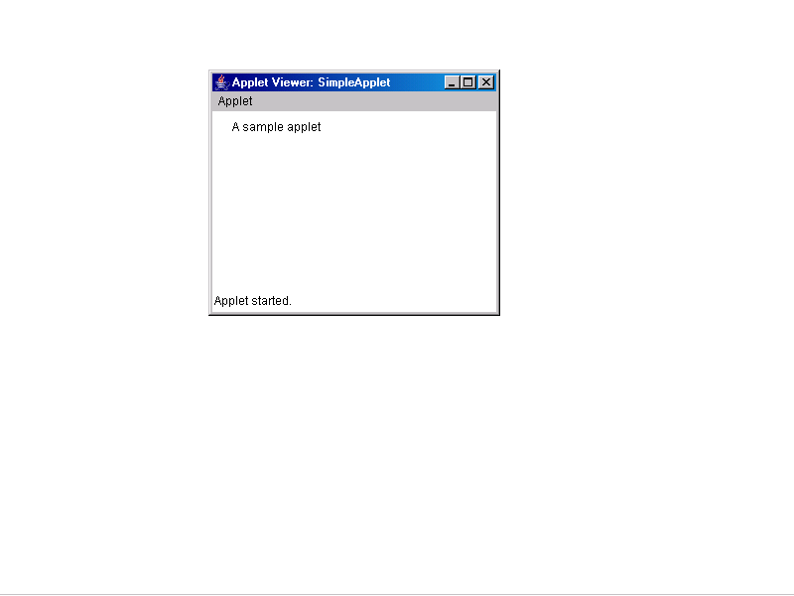

24
/* Develop an applet that receives an integer in one text field, and computes its factorial value and returns it in another text field, when the button named “Compute” is clicked.*/

import java.awt.*;
import java.applet.*;
import java.awt.event.*;
//<applet code="SApplet" width=300 height=240></applet>
public class SApplet extends Applet implements ActionListener
{
String msg=" ";
TextField f1,f2;
Button b;
Label l,l1,l2;
public void init()
{
f1=new TextField("",5); f2=new TextField("",10);
b=new Button("compute");
l= new Label("enter value of A:");
l2=new Label("fact of A");
l1=new Label("week six prgm B");
setLayout(null);
l1.setBounds(10,10,120,30); l.setBounds(10,35,120,30);
f1.setBounds(10,60,120,30); l2.setBounds(10,85,120,30);
f2.setBounds(10,110,120,30); b.setBounds(10,140,120,30);
add(l1); add(l);
add(f1); add(l2);
add(f2); f2.setEnabled(false);
add(b); b.addActionListener(this);
}
public void actionPerformed(ActionEvent e)
{
if(e.getActionCommand().equals("compute"))
{
int n=Integer.parseInt(f1.getText());
int i=1,f=1;
while(i<=n)
{
f=f*i;
i=i+1;
}
f2.setText(""+f);
}
}
25

public void paint(Graphics g)
{
g.drawString("simple applet with events",10,200);
}
}

Output:

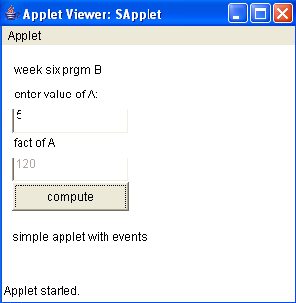

26

/*.Write a Java program that works as a simple calculator. Use a grid layout to arrange buttons for the digits and for the +, -,*, % operations. Add a text field to display the result.*/

import javax.swing.*;
import javax.swing.JOptionPane;
import java.awt.*;
import java.awt.event.*;
/*
<applet code="Calculator" height=300 width=200>
</applet>
*/
public class Calculator extends JApplet
{
public void init()
{
CalculatorPanel calc= new CalculatorPanel();
getContentPane().add(calc);
}
}

class CalculatorPanel extends JPanel implements ActionListener
{
JButton n1,n2,n3,n4,n5,n6,n7,n8,n9,n0,plus,minus,mul,div,dot,equal;
static JTextField result= new JTextField("0",45);
static String lastCommand=null;
JOptionPane p= new JOptionPane();
double preRes=0,secVal=0,res;
private static void assign(String no)
{
if((result.getText()).equals("0"))
result.setText(no);
else if(lastCommand=="=")
{
result.setText(no);
lastCommand=null;
}
else
result.setText(result.getText()+no);
}

27
public CalculatorPanel()
{
setLayout(new BorderLayout()); result.setEditable(false);
result.setSize(300,200); add(result,BorderLayout.NORTH);
JPanel panel=new JPanel();
panel.setLayout(new GridLayout(4,4));
n7=new JButton("7"); panel.add(n7);
n7.addActionListener(this); n8=new JButton("8");
panel.add(n8); n8.addActionListener(this);
n9=new JButton("7"); panel.add(n9);
n9.addActionListener(this); div=new JButton("/");
div.addActionListener(this); n4=new JButton("4");
panel.add(n4); n4.addActionListener(this);
n5=new JButton("5"); panel.add(n5);
n5.addActionListener(this); n6=new JButton("6");
panel.add(n6); n6.addActionListener(this);
mul= new JButton("*"); panel.add(mul);
mul.addActionListener(this); n1=new JButton("1");
panel.add(n1); n1.addActionListener(this);
n2=new JButton("2"); panel.add(n2);
n2.addActionListener(this); n3=new JButton("3");
panel.add(n3); n3.addActionListener(this);
minus=new JButton("-"); panel.add(minus);
minus.addActionListener(this); dot= new JButton(".");
panel.add(dot); dot.addActionListener(this);
n0=new JButton("0"); panel.add(n0);
n0.addActionListener(this); equal=new JButton("=");
panel.add(equal); equal.addActionListener(this);
plus=new JButton("+"); panel.add(plus);
plus.addActionListener(this); add(panel,BorderLayout.CENTER);
}
public void actionPerformed(ActionEvent ae)
{ if(ae.getSource()==n1) assign("1");
else if(ae.getSource()==n2) assign("2");
else if(ae.getSource()==n3) assign("3");
else if(ae.getSource()==n4) assign("4");
else if(ae.getSource()==n5) assign("5");
else if(ae.getSource()==n6) assign("6");
else if(ae.getSource()==n7) assign("7");
else if(ae.getSource()==n8) assign("8");
else if(ae.getSource()==n9) assign("9");
else if(ae.getSource()==n0) assign("0");

28
else if(ae.getSource()==dot)
{
if(((result.getText()).indexOf("."))==-1)
result.setText(result.getText()+".");
}
else if(ae.getSource()==minus)
{ preRes=Double.parseDouble(result.getText());
lastCommand="-"; result.setText("0");
}
else if(ae.getSource()==div)
{ preRes=Double.parseDouble(result.getText());
lastCommand="/"; result.setText("0");
}
else if(ae.getSource()==equal)
{
secVal=Double.parseDouble(result.getText());
if(lastCommand.equals("/"))
res=preRes/secVal;
else if(lastCommand.equals("*"))
res=preRes*secVal;
else if(lastCommand.equals("-"))
res=preRes-secVal;
else if(lastCommand.equals("+"))
res=preRes+secVal;
result.setText(" "+res); lastCommand="=";
}
else if(ae.getSource()==mul)
{ preRes=Double.parseDouble(result.getText());
lastCommand="*"; result.setText("0");
}
else if(ae.getSource()==plus)
{ preRes=Double.parseDouble(result.getText());
lastCommand="+"; result.setText("0");
}
}
}

29

Output:

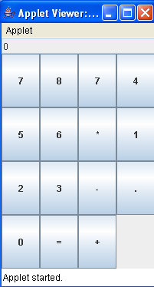

30

/* .Write a java program for handling mouse events*/

import java.awt.*;
import java.applet.*;
import java.awt.event.*;
/*
<applet code="MouseEvents" width=300 height=500>
</applet>
*/
public class MouseEvents extends Applet implements MouseListener,MouseMotionListener
{
String msg=" ";
int mouseX=0,mouseY=0;
public void init()
{ addMouseListener(this);
addMouseMotionListener(this);
}
public void mouseClicked(MouseEvent me)
{ mouseX=0; mouseY=10;
msg="mouseClicked";
repaint();
}
public void mouseEntered(MouseEvent me)
{ mouseX=0; mouseY=10;
msg="mouse entered";
repaint();
}
public void mouseExited(MouseEvent me)
{ mouseX=0; mouseY=10;
msg="mouse exited";
repaint();
}
public void mousePressed(MouseEvent me)
{ mouseX=me.getX(); mouseY=me.getY();
msg="mouse pressed";
repaint();
}
public void mouseReleased(MouseEvent me)
{ mouseX=me.getX(); mouseY=me.getY();
msg="Mouse Released";
repaint();
} 31

public void mouseDragged(MouseEvent me)
{
mouseX=me.getX(); mouseY=me.getY();
msg="mouse dragged";
showStatus("Dragging mouse at"+mouseX+","+mouseY);
repaint();
}
public void mouseMoved(MouseEvent me)
{
mouseX=me.getX(); mouseY=me.getY();
showStatus("Moving mouse at"+mouseX+","+mouseY);
}
public void paint(Graphics g)
{
g.drawString(msg,mouseX,mouseY);
}
}

Output:
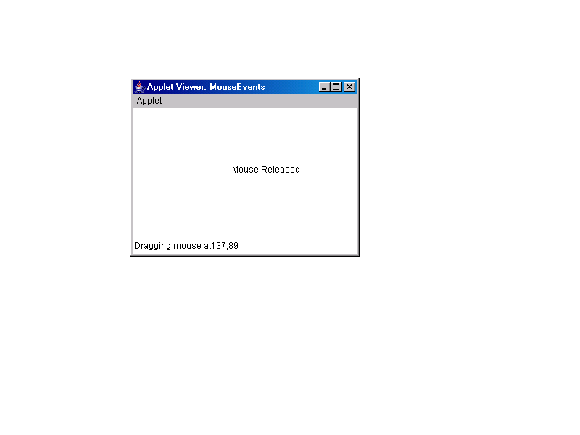

32

/* Write a java program for creating multiple threads*/
class NewThread implements Runnable
{
String name;
Thread t;
NewThread(String threadname)
{ name=threadname;
t=new Thread(this,name);
System.out.println("New thread"+t);
t.start();
}
public void run()
{ try
{ for(int i=5;i>0;i--)
{ System.out.println(name+":"+i);
Thread.sleep(1000);
}
}
catch(InterruptedException e)
{ System.out.println(name+"Interrupted");
}
System.out.println(name+"exiting");
}
}
class MultiThreadDemo
{ public static void main(String[] args)
{ new NewThread("One"); new NewThread("Two");
new NewThread("Three");
try
{ Thread.sleep(10000);
}
catch(InterruptedException e)
{ System.out.println("Main Thread Interuppted");
}
System.out.println("Main thread exiting");
}
}

33

Output:
New threadThread[One,5,main]
New threadThread[Two,5,main]
One:5
New threadThread[Three,5,main]
Two:5
Three:5
One:4
Two:4
Three:4
One:3
Two:3
Three:3
One:2
Two:2
Three:2
One:1
Two:1
Three:1
Oneexiting
Twoexiting
Threeexiting
Main thread exiting

34

/* Write a java program that correctly implements producer consumer problem using the concept of inter thread communication */
class Q
{ int n;
boolean valueset=false;
synchronized int get()
{
if(!valueset)
try
{ wait();
}
catch(InterruptedException e)
{
System.out.println("caught");
}
System.out.println("get:"+n);
valueset=false;
notify(); return n;
}
synchronized void put(int n)
{
if(valueset)
try
{ wait();
}
catch(InterruptedException e)
{ System.out.println("caught");
}
this.n=n; valueset=true;
System.out.println("put:"+n);
notify();
}
}
class Producer implements Runnable
{ Q q;
Producer(Q q)
{
this.q=q; new Thread(this,"Producer").start();
}
public void run()
{
int i=0;
35

while(true)
{ q.put(i++);
}
}
}
class Consumer implements Runnable
{ Q q;
Consumer(Q q)
{
this.q=q; new Thread(this,"Consumer").start();
}
public void run()
{
while(true)
{ q.get();
}
}
}
class Pc
{
public static void main(String[] args)
{
Q q=new Q();
new Producer(q); new Consumer(q);
System.out.println("press ctrl+c to stop");
}
}

Output:
press ctrl+c to stop
put:0
get:0
put:1
get:1
put:2
get:2

36

/*Write a program that creates a user interface to perform integer divisions. The user enters two numbers in the textfields, Num1 and Num2. The division of Num1 and Num2 is displayed in the Result field when the Divide button is clicked. If Num1 or Num2 were not an integer, the program would throw a NumberFormatException. If Num2 were Zero, the program would throw an ArithmeticException Display the exception in a message dialog box.*/

import javax.swing.*;
import java.awt.*;
import java.awt.event.*;
import java.text.DecimalFormat;
public class DivideByZeroTest extends JFrame implements ActionListener{
private JTextField input1,input2,output;
private int number1,number2;
private double result;
public DivideByZeroTest()
{
super("Demonstrating Exceptions"); Container c=getContentPane();
c.setLayout(new GridLayout(3,2));
c.add(new JLabel("Enter Numerator",SwingConstants.RIGHT));
input1= new JTextField(10); c.add(input1);
c.add(new JLabel("Enter Denominator and press Enter",SwingConstants.RIGHT));
input2= new JTextField(10); c.add(input2);
input2.addActionListener(this);
c.add(new JLabel("RESULT",SwingConstants.RIGHT));
output=new JTextField(); c.add(output);
setSize(425,100); show();
}
public void actionPerformed(ActionEvent ae)
{
DecimalFormat precision3=new DecimalFormat("0.000");
output.setText(" ");
try{ number1=Integer.parseInt(input1.getText());
number2=Integer.parseInt(input2.getText());
result=quotient(number1,number2);
output.setText(precision3.format(result));
}
catch(NumberFormatException nfe)
{
JOptionPane.showMessageDialog(this,"you must enter two integers","Invalid number foprmat",JOptionPane.ERROR_MESSAGE);
}
37
catch(DivideByZeroException dbze)
{
JOptionPane.showMessageDialog(this,dbze.toString(),"Attempted to Divide By Zero",JOptionPane.ERROR_MESSAGE);
}
}
public double quotient(int numerator,int denominator)throws DivideByZeroException
{
if(denominator==0)
throw new DivideByZeroException();
return (double)numerator/denominator;
}

public class DivideByZeroException extends ArithmeticException
{
public DivideByZeroException()
{
super("attempted to dividebyzero");
}
public DivideByZeroException(String message)
{
super(message);
}
}
public static void main(String args[])
{
DivideByZeroTest app=new DivideByZeroTest();
app.addWindowListener(
new WindowAdapter(){
public void windowClosing(WindowEvent e)
{
e.getWindow().dispose();
System.exit(0);
}
}
);
}
}

38
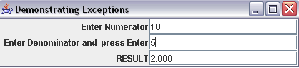

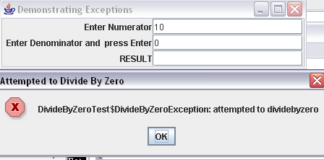

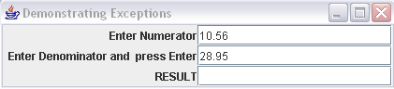

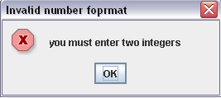

39

/*Write a Java program that implements a simple client/server application. The client sends data to a server. The server receives the data, uses it to produce a result, and then sends the result back to the client. The client displays the result on the console. For ex: The data sent from the client is the radius of a circle, and the result produced by the server is the area of the circle. (Use java.net)*/

import java.io.*;
import java.net.*;
class Client{
public static void main(String args[])throws Exception
{
Socket s=new Socket("localhost",777);
DataOutputStream dos=new DataOutputStream(s.getOutputStream());
BufferedReader br=new BufferedReader(new InputStreamReader(s.getInputStream()));
BufferedReader kb=new BufferedReader(new InputStreamReader(System.in));
String str,str1;
while(!(str=kb.readLine()).equals("exit"))
{
dos.writeBytes(str+"\n");
str1=br.readLine();
System.out.println(str1);
}
s.close();
dos.close();
br.close();
kb.close();
}
}

40

import java.io.*;
import java.net.*;
class Server{
public static void main(String args[])throws Exception
{
ServerSocket ss=new ServerSocket(777);
Socket s=ss.accept();
System.out.println("connection established...");
PrintStream ps=new PrintStream(s.getOutputStream());
BufferedReader br=new BufferedReader(new InputStreamReader(s.getInputStream()));
BufferedReader kb=new BufferedReader(new InputStreamReader(System.in));
while(true)
{
String str,str1;
double area,a1;
while((str=br.readLine())!=null)
{
System.out.println(str);
a1=Integer.parseInt(str);
area=a1*a1*3.14;
ps.println(""+area);
}
ps.close();
br.close();
kb.close();
ss.close();
s.close();
System.exit(0);
}
}
}

41

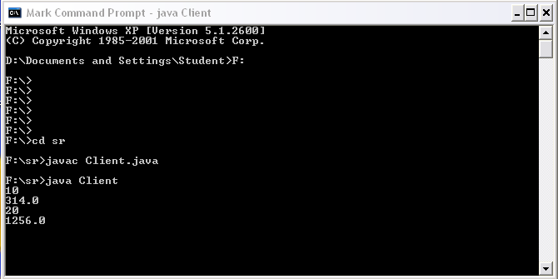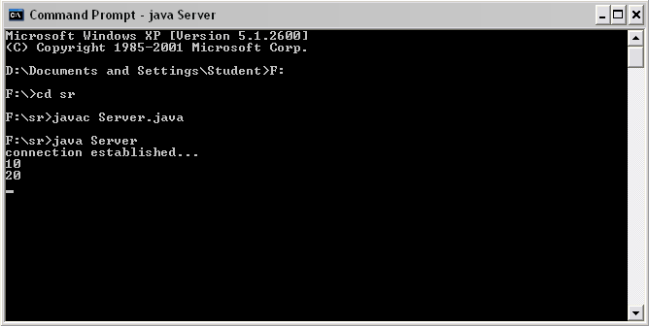

42

/* Write a java program that simulates a traffic light. The program lets the user select one of three lights: red, yellow, or green. When a radio button is selected, the light is turned on, and only one light can be on at a time No light is on when the program starts.*/

import java.awt.*;
import java .awt.event.*;
import javax.swing.*;
public class Trafficlight extends JFrame implements ActionListener
{ JTextField tf;
JRadioButton b1,b2,b3;
Container c;
String str;
Trafficlight()
{ c=getContentPane(); c.setLayout(new FlowLayout());
b1=new JRadioButton("RED"); b2=new JRadioButton("GREEN");
b3=new JRadioButton("BLUE");
ButtonGroup bg= new ButtonGroup();
bg.add(b1); bg.add(b2); bg.add(b3);
c.add(b1); c.add(b2); c.add(b3);
b1.addActionListener(this); b2.addActionListener(this);
b3.addActionListener(this);
setDefaultCloseOperation(JFrame.EXIT_ON_CLOSE);
}
public void actionPerformed(ActionEvent ae)
{
str=ae.getActionCommand() repaint();
}
public void paint (Graphics g)
{
if(str.equals("RED"))
{ g.drawRect(100,100,100,300); g.setColor(Color.red);
g.fillOval(110,160,30,30); g.setColor(Color.black);
g.fillOval(110,220,30,30); g.setColor(Color.black);
g.fillOval(110,290,30,30);
}
else if(str.equals("GREEN"))
{
g.drawRect(100,100,100,300); g.setColor(Color.black);
g.fillOval(110,160,30,30); g.setColor(Color.green);
g.fillOval(110,220,30,30); g.setColor(Color.black);
g.fillOval(110,290,30,30);
}
43

else if(str.equals("BLUE"))
{ g.drawRect(100,100,100,300); g.setColor(Color.black);
g.fillOval(110,160,30,30); g.setColor(Color.black);
g.fillOval(110,220,30,30); g.setColor(Color.blue);
g.fillOval(110,290,30,30);
}
}
public static void main(String args[])
{ Trafficlight tf=new Trafficlight ();
tf.setTitle("my buttons");
tf.setSize(700,700); tf.setVisible(true);
}
}

OUTPUT:

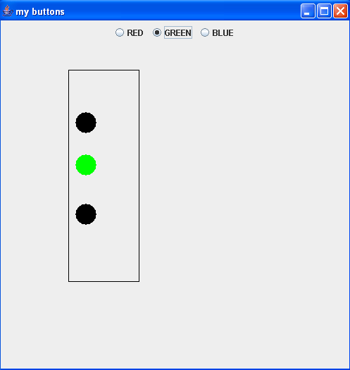

44

/* Write a java program that allows the user to draw lines, rectangle and ovals.*/

import java.awt.*;
import java.applet.*;
/* <applet code="MyGraphics" width=300 height=300>
</applet>
*/
public class MyGraphics extends Applet
{
int x[]={10,20,30,20,10};
int y[]={20,5,20,25,20};
public void init()
{
setForeground(Color.black);
setBackground(Color.white);
}
public void paint(Graphics g)
{
g.drawLine(10,20,40,20);
g.drawLine(60,20,60,80);
g.drawLine(120,20,90,80);
g.drawLine(170,20,200,80);
g.drawRect(10,100,30,10);
g.fillRect(10,130,30,10);
g.drawRoundRect(100,100,30,10,5,5);
g.fillRoundRect(100,130,30,10,5,5);
g.drawOval(10,160,30,40);
g.fillOval(100,160,30,40);
}
}

45

Output:
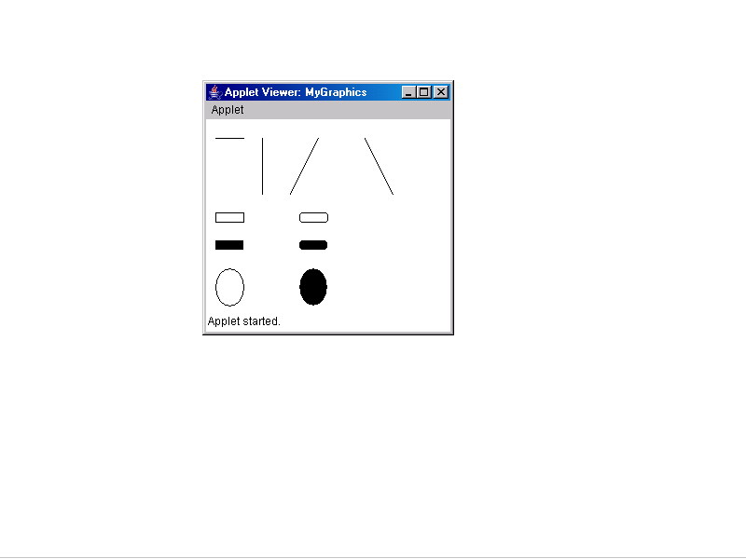

46

/* Write a java program to create an abstract class named Shape that contains an empty method named numberOfSides ( ).Provide three classes named Trapezoid, Triangle and Hexagon such that each one of the classes extends the class Shape. Each one of the classes contains only the method numberOfSides ( ) that shows the number of sides in the given geometrical figures.*/

abstract class Shape
{ abstract void numberOfSides(int s);
}
class Trapezoid extends Shape
{ void numberOfSides(int s)
{ System.out.println("the no of sides of a trapizoid is "+s);
}
}
class Triangle extends Shape
{
void numberOfSides(int s)
{ System.out.println("the no of sides of a triangle is "+s);
}
}
class Hexagonal extends Shape
{
void numberOfSides(int s)
{ System.out.println("the no of sides of a Hexagonal is "+s);
}
}
class UseShape
{
public static void main(String args[])
{ Trapezoid t=new Trapezoid();
Triangle tr=new Triangle();
Hexagonal h=new Hexagonal();
Shape s;
s=t; s.numberOfSides(4);
s=tr; s.numberOfSides(3);
s=h; s.numberOfSides(6);
}
}

47

Output:

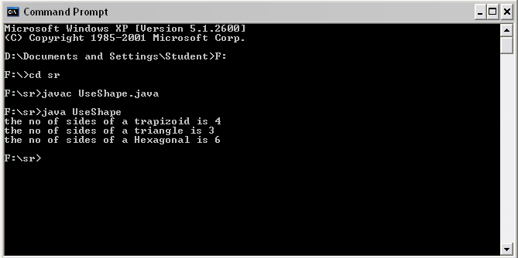

48

